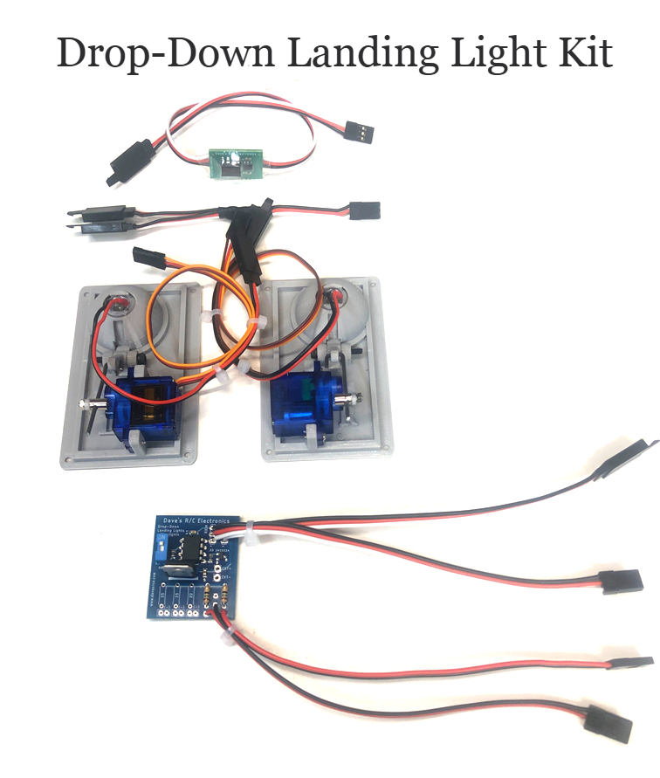
Drop-Down Landing Light Kit

The Drop-Down Landing Light Kit contains everything you need to add a set of Drop-Down Landing Lights to your model, and includes:
- The control board that rotates the servos up/down and turns the landing lights on/off
- Two 3D printed mechanisms, one for the right wing and one for the left wing, which hold the servos and the drop-down cups into which the LEDs are mounted
- The servos, servo arms, control rods, and adapters
- The 8mm ½-watt Straw-Hat LEDs
- Chrome reflectors to increase the LEDs’ visibility
- Extension wires for the servos and LEDs
The control board plugs directly into the receiver and allows you to control the lights from a single channel. New programming allows you to set the end points for the servos using the settings in your transmitter and imports those end points into the program so you can adjust the movement of the servos precisely and easily.
INSTALLATION:
Install the Drop-Down Mechanisms into the bottom of each wing panel as required. The Left and Right mechanisms must be installed in the correct wing side, and the servos connected to the circuit board in the Left/Right cables as marked. The servos rotate in opposite directions, so it’s very important to identify the correct parts and cables and make sure they are installed properly.
SETUP:
Before use you need to set the end points for the channel being used for the lights by connecting a servo directly into the receiver. Adjust the end points of the channel so that the drop-down cup moves all the way up and all the way down, without binding or buzzing.

(continued on back)
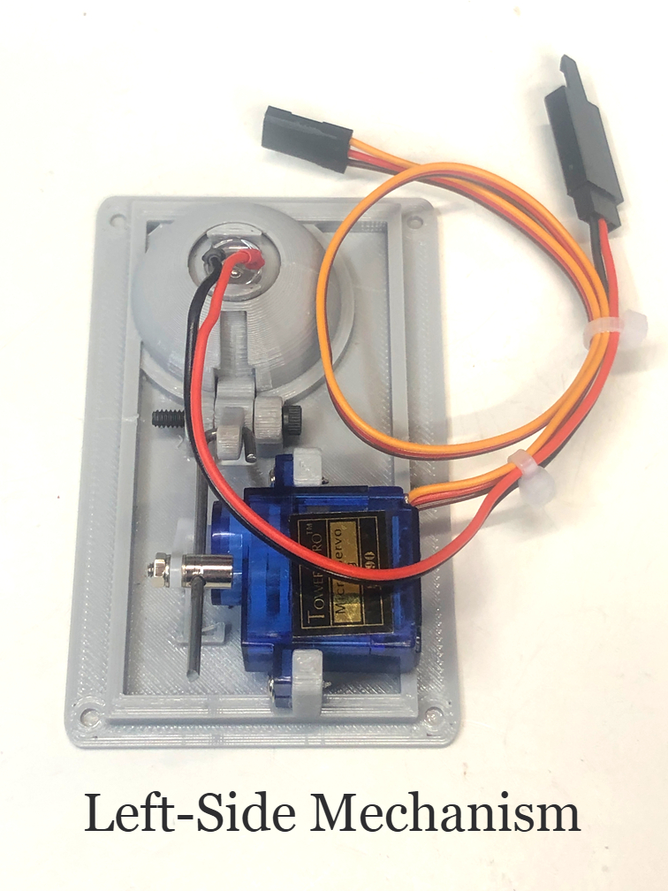
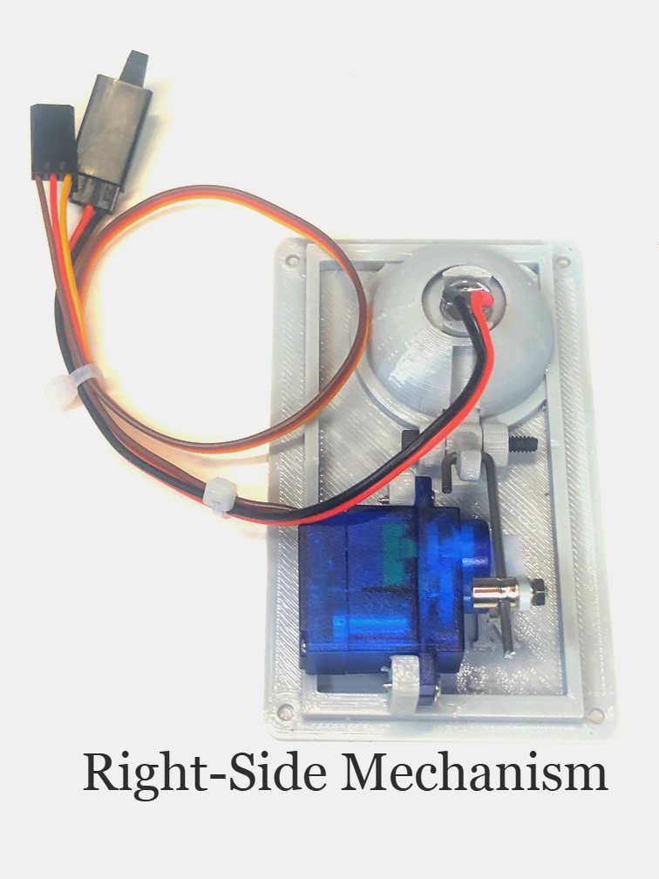
I strongly recommend that you begin with the end points at 75% in both directions and adjust up or down from those points. The servos are mounted, and the control rods pre-adjusted in expectation of these (75%) end points. If you use these settings, you should be able to install the drop-down mechanisms and begin using them without any other adjustments. Plug both servo into the circuit board and plug the circuit board into the receiver. Connect the wires for the two LEDs to the appropriate cables, and assign a switch on your radio to control the channel. Servo reversing is now done by the control board, so a servo reverser is no longer necessary.

OPERATION:
To prevent damage to the drop-down cups, programming prevents the servo from moving when the receiver is first powered. Once the switch has been moved from its initial position, the mechanism will move to the indicated position (either up or down), and the landing lights will go on/off, depending on the position of the switch. Now you can cycle the switch back and forth, and the mechanism will move up/down, turning the landing lights on/off as necessary.

The small blue switch on the upper left side of the board will toggle the light on/off with regard to the position of the cup, to allow for compatibility with replacement servos that might operate in the opposite direction. If your light is “on” when it should be “off”, just toggle this switch.

The correct position for this switch (for most servos) in “down” or “OFF”. The movement of the drop-down cup is slightly slowed, to make the movement of the cups more scale-like and smoother. Fine adjustments to the positions of the drop-down cups can be made to the length of the control rods using the adapters mounted on the servo arms, just like any other control surface.

If you have any questions or problems, don’t hesitate to contact me. ENJOY!

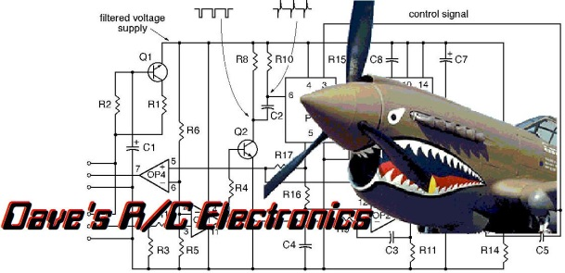
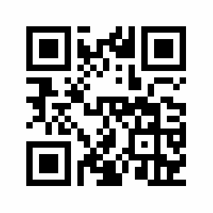
www.davesrce.com
sales@davesrce.com
(423) 544-1657
SCAN HERE

