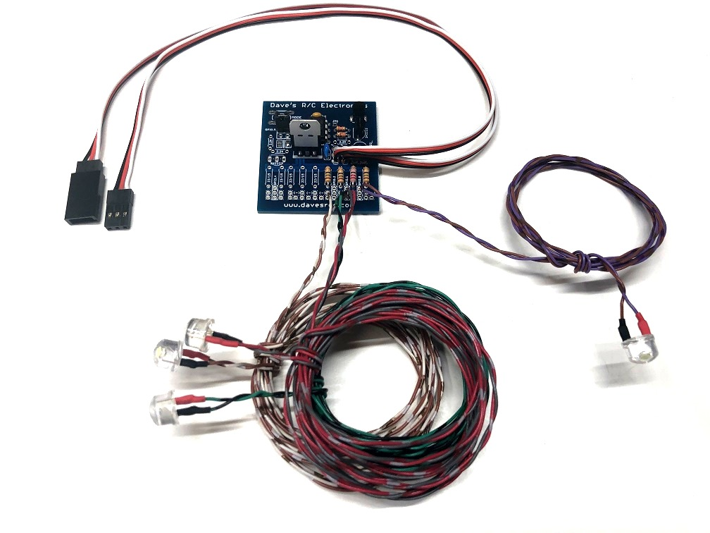
Drop-Down Landing Light with NavLights

The Drop-Down Landing Light w/NavLights is designed to provide scale-like control of the Landing Light on a model that has a panel on the bottom of the wing that lowers when the landing lights are toggled on. When the circuit is activated, it sends a signal to a standard, proportional servo to rotate the wing panel down, while turning the 8mm ½ watt Straw Hat LED “On”. It also provides control of the Navigation Lights on the Wingtips and the Tailcone, independent of the action of the Landing Light. A small jumper on the board allows the modeler to reverse the rotation of the servo, without the need to reverse the channel in the radio, making setup easier and more compatible with other circuits that may share the channel.
The circuit features three distinct modes. Mode 1 is All Lights Off. Mode 2 turns the Navigation Lights On. In Mode 3, all Lights are ON, including the Landing Lights, and the servo is rotated to lower the panel on the wing that contains the Landing Light. The modes are toggled by advancing the channel into which the circuit is connected, and for this reason the unit must be plugged into a proportional channel like the flap channel or higher, rather than the gear channel. Consult the manual for your specific transmitter for instructions on programming a mix that will allow you to use a 3-position switch to control the three modes. The chart below shows the approximate channel settings used to achieve the three modes of operation. (Futaba settings are listed first, Spektrum/others listed in parentheses.)

Mode | Function | Channel Setting
Mode 1 | All Lights OFF | less than -50% (or less than 30%)
Mode 2 | Wingtips, Strobes, Tailcone ON | -50 to 0%-center (or 25-50%)
Mode 3 | All Lights ON (including Landing) | greater than 0% (or greater than 50%)

(continued on back)

You can change the channel’s settings “on the fly” to achieve the proper operation of the 3 modes. The mix for Mode 1 should be set with the channel at -100% (or -0%), and with the switch in the position you want for Mode 1. Switch to the next mix, move the transmitter’s switch to the position you want to use for Mode 2, and increase the channel’s setting to somewhere around the center of the channel, 0% (or 50%) or until all the lights except the landing lights come on. Now switch to the third mix, move the transmitter’s switch to the position you want for Mode 3, and increase the mix past center, > 50% (or +70%) until the landing light comes on. Now you’re set!

The LEDs are powered from the receiver’s battery pack, and since this circuit is regulated, it can be used on any receiver and any size or voltage receiver battery, including HV (high voltage) receivers. Total current draw is still very low, so there is no need for a separate power source.

If you have any questions or problems, don’t hesitate to contact me. ENJOY!
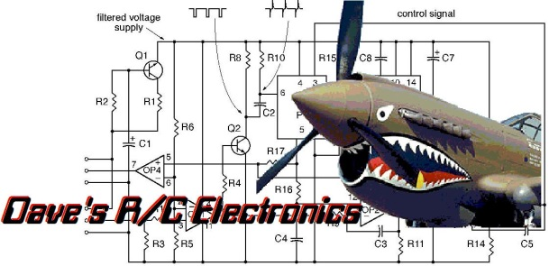
www.davesrce.com
sales@davesrce.com
(423) 544-1657
SCAN HERE

