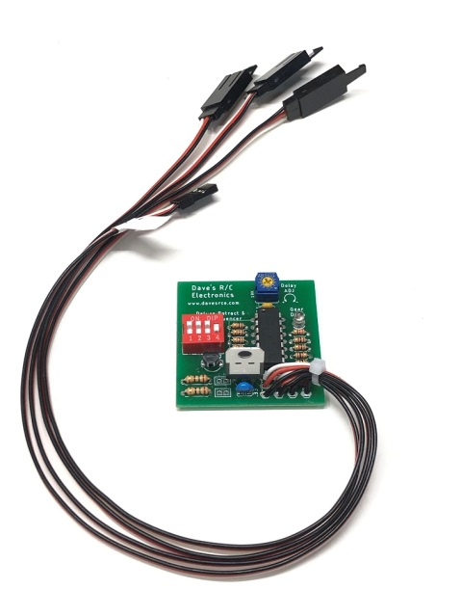
Deluxe Twin Retract & Gear Door Sequencer

The Deluxe Twin Retract & Gear Door Sequencer is designed to provide coordinated control of the retract controllers and gear door servos used on a plane equipped with two retract servos and gear doors, and utilizes a microprocessor to control all three outputs. It also features Landing Lights that automatically come on when the gear are down, and provides the option of leaving the gear door(s) open after the gear have been lowered (P-47 style), or having the gear door(s) close after the gear are down (P-51 style). An adjustable delay allows the modeler to time the opening/closing of the model’s gear doors to accommodate the speed of the model’s retracts. This version of the circuit features two main gear outputs, one for the main gear servo, one for the secondary gear servo, and one for the gear doors.

The controller can be located inside the model in any convenient location. The female servo lead from the controller will normally be connected to the receiver’s gear channel, although it can be connected to any spare channel and activated via a program mix. One male servo leads is connected to the retract controller, the second is connected to the main gear door servo(s), and the third is connected to the second (aft) gear door servo(s) All are clearly marked. A small, blue trim potentiometer near the top of the circuit board provides adjustment for the delay function, which can range from about 4 seconds to approximately 15 seconds Turning the screw counter-clockwise (CCW) decreases the delay, turning clockwise (CW) increases the delay. The red Option Switches on the left side of the board control the other functions of the sequencer. Switch #1 toggles the action of the entire circuit, making it easier to sync the sequencer with other devices you may have connected to your receiver. It functions exactly like the reversing function in your transmitter’s menu, toggling it from on to off will swap the up/down action of the retracts. Switch #2 reverses the direction (rotation) of the gear door servo(s), to facilitate easier setup with different model configurations. This switch reverses both the main and aft servo output. Switch #3 controls whether or not the gear doors close after the gear have been lowered. If “Off”, the doors will remain open after the gear have been lowered, if “On”, they will close. (Gear doors will always close after the gear have been raised.) Switch #4 is used to choose between electric retracts and air retracts. If this switch is “On”, the circuit is set for electric retracts. If “Off”, the output to the retracts will be limited to accommodate the smaller movement necessary for an air-valve servo.

(continued on back)
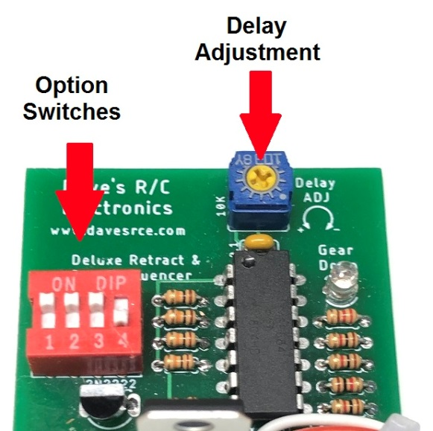
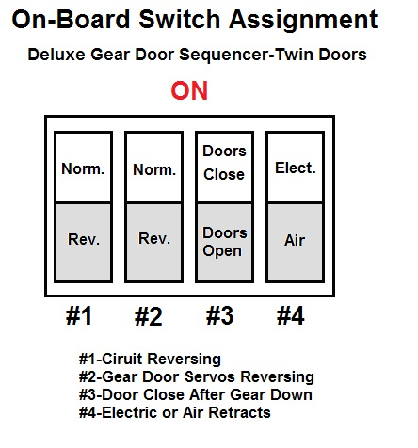
To prevent damage to your gear doors, new programming prevents either servo from moving when the receiver is first powered. Once the gear switch has been cycled once, the retract controller will move to the indicated position, and the gear doors will cycle in accordance to the way they are set up using the instructions that follow. Follow them carefully to prevent damage to your gear doors during the initial setup.

Leave the linkage to your gear door servo(s) disconnected until you have completed steps 1 through 7 completely!

1. Set Option Switch #4 to the correct position for the type of retracts you have, either Electric (Up), or Air (Down).
2. If you want the gear doors to close after the gear have been lowered, turn the screw on the small pot located at the top edge of the circuit board fully clockwise (CW). This will provide maximum delay for the setup procedure.
3. Make Option Switches #1, #2, & #3 are “OFF”. This will prevent the gear doors from closing until you have established the correct direction of rotation for your gear door servo(s), and have made sure that the gear switch on your transmitter is operating in the direction you prefer.
4. Connect the cables from your retract controller and gear door servos to the proper male servo leads as marked. Connect the cable marked “To Receiver” to your receiver’s gear channel, or to the channel of your choice.
5. Power your receiver on. Note that the retracts and gear door servos will not move until you cycle the gear switch on the transmitter one time. Toggle it, and note the yellow LED on the main circuit board, it will indicate which mode the sequencer is in. If the yellow LED is On, that is the Gear Down mode. If it is off, that is the Gear Up mode. Move the switch on your transmitter to the position you prefer for Gear Down, and note if the LED is on. If it is not, simply toggle Option Switch #1. Cycle the gear switch several times to make sure the sequencer is now in sync with the position of the retracts. Once your gear move up and down correctly and are in sync with the sequencer you may proceed to step 6.
6. Note the direction that the gear door servos are rotating, either clockwise or counter-clockwise (CW or CCW). If they are rotating in the wrong direction, move Option Switch #2 to the “ON” position. Cycle the gear up and down several times to verify that the gear door servos are moving in the right direction to open the gear doors when the gear are down, and close them when the gear are up.

7. If you want the aft gear doors to remain open after the gear are down, make sure Option Switch #3 is in the “OFF” position, and skip to Step 8. If you want the aft gear doors to close after the gear have moved “Down” (P-51 style), move Option Switch #3 to the “ON” position. Cycle the gear to the “Gear Down” position, and note the delay between the time the gear are fully down and locked and the closing of the aft gear doors. (Be patient, the initial delay will be about 15 seconds.) If the delay is too long, turn the screw on the pot counter-clockwise (CCW) in small increments and cycle the gear again. Repeat until you find the setting that provides the correct timing for your retracts.
8. Now connect the linkages to the gear door(s) and make any necessary final adjustments.

Following the steps above should ensure that your sequencer works smoothly and reliably.

If you have any questions or problems, don’t hesitate to contact me. ENJOY!
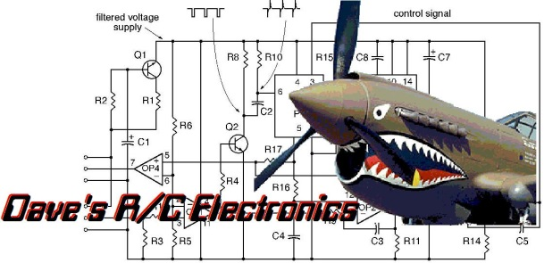
www.davesrce.com
sales@davesrce.com
(423) 544-1657
SCAN HERE

