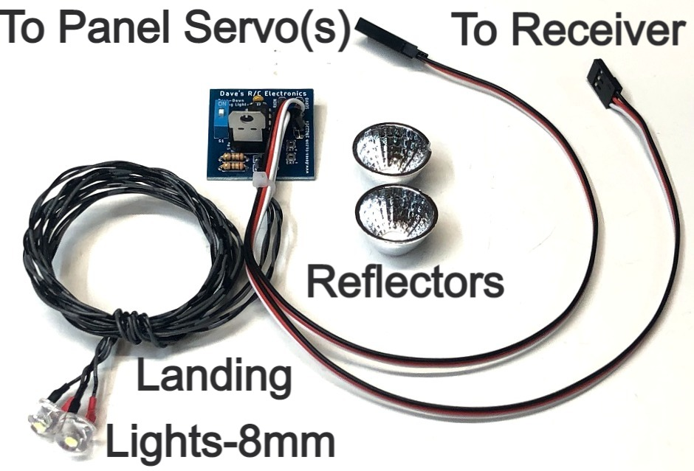

ATV Drop-Down Landing Lights

The Drop-Down Landing Lights is designed to provide scale-like control of the Landing Lights on a model that has a panel on the bottom of the wing that lowers when the landing lights are toggled on. When the circuit is activated, it sends a signal to a standard, proportional servo to rotate the wing panel down, while turning the 8mm ½ watt Straw Hat LED “On”. This circuit can be used in conjunction with retracts or flaps, allowing you to use a single channel for both. A small switch on the board allows the modeler to reverse the rotation of the servo, without the need to reverse the channel in the radio, making setup easier and more compatible with other circuits, like retracts or flaps, that may share the channel. This circuit can be used to drive two servos by simply adding a standard servo Y to the servo output coming from the control board. This new ATV version features new programming that allows the modeler to import the end points for the servo(s) from the transmitter, making adjustment of the drop-down mechanism much easier.
Before use you should establish the proper range of movement for your drop-down servo(s) by plugging it into the channel used for the circuit (usually the gear channel) and adjusting the end points of that channel using your transmitter. Once you have the servo moving up and down completely in both directions, so that the servo is moving fully up/down, with no binding or servo buzzing, you can proceed with the rest of the setup instructions.
The circuit features two modes. Mode #1 is Landing Light Off, and the panel is raised into the wing. Mode #2 turns the Landing Lights On, and rotates the servo to lower the panel on the wing that contains the Landing Light. The modes are toggled by moving the channel into which the circuit is connected from one side of the channel’s “center” to the other. Note that if you are going to use this circuit in one channel combined with flaps or retracts, the channel must be set to start on the low side of “center”, i.e. -100%”, and move to the high side of center, i.e. +100% when the channel’s switch, knob, or slider is moved. Your actual end points can be closer to the cannel’s center, but they must cross the channel center to toggle the circuit.

If you have any questions or problems, don’t hesitate to contact me. ENJOY!
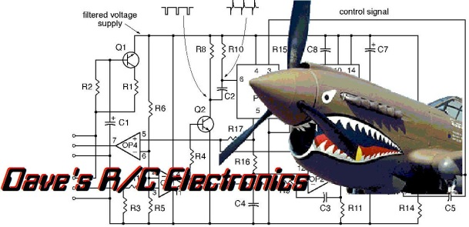

www.davesrce.com
sales@davesrce.com
(423) 544-1657
SCAN HERE

