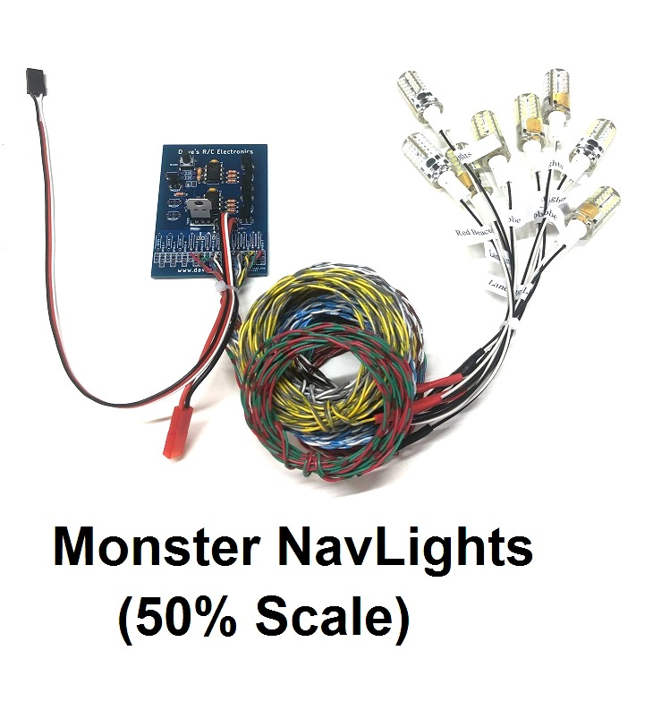
The Monster NavLights Set includes 2 Wingtip Lights (1-red, 1-green), 2 Wingtip Strobes (white), 1 Tailfin Strobe (white), 1 Simulated Rotating Beacon (red), and 2 Landing Lights (white). The Wingtip Strobes are pre-set in a double-blink pattern, and they blink asynchronously with each other. The Tailfin Strobe and the Simulated Rotating Beacon have multiple patterns that can be selected from the main circuit board via a small pushbutton switch located in the upper left-hand corner. The 4 available patterns provide either a single or double-blink strobe and two different “speeds” for the Simulated Rotating Beacon. The circuit is powered externally by a 3S 11.1 volt Li-Po battery, we recommend an 1800mA or larger capacity.
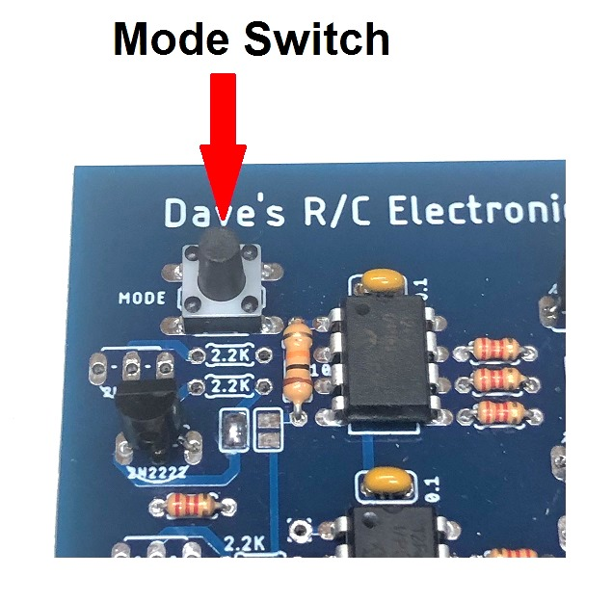
The 4 available patterns can be selected via the small pushbutton switch on the main circuit board. (See picture above). The 4 patterns are listed below:

#1: Single-blink Strobe/Fast Beacon speed #3: Double-blink Strobe/Fast Beacon speed
#2: Single-blink Strobe/Normal Beacon speed #4: Double-blink Strobe/Normal Beacon speed

(continued on back)

The circuit is controlled by the transmitter, and features three distinct modes. Mode 1 is All Lights Off. Mode 2 turns the Wingtip Lights (2), Wingtip Strobes (2), Tailfin Strobe, and Rotating Beacon ON. In Mode 3, all Lights are ON, including the Landing Lights (2). The modes are toggled by advancing the channel into which the circuit is connected, and the unit must be plugged into a proportional channel like the flap channel or higher, rather than the gear channel. Consult the manual for your specific transmitter for instructions on programming a mix that will allow you to use a 3-position switch to control the various modes. The chart below shows the approximate channel settings used to achieve the three modes of operation.

Mode | Function | Channel Setting
Mode 1 | All Lights OFF | less than ~ 30% (or -20%)
Mode 2 | Wingtips, Strobes, Tailcone ON | ~30% to ~ 70% (or ~0% )
Mode 3 | All Lights ON (including Landing) | ~greater than 70% (or +20%)

You can change the channel’s settings “on the fly” to achieve the proper operation of the 3 modes. Mode 1 should be set with the channel at 0% (or -100%). Switch to the next mix, toggle the transmitter’s switch to the position you want to use for Mode 2, and increase the channel’s setting to somewhere around the center of the channel (50% or 0%) until all the lights except the landing lights come on. Next, switch to the third mix, toggle the transmitter’s switch to the third position, and increase the mix ( > 50% or +20%) until the landing lights come on. Now you’re set!
The LEDs are powered from the receiver’s battery pack, and since this circuit is regulated, it can be used on any receiver and any size or voltage receiver battery, including HV (high voltage) receivers. Total current draw is still very low, so there is no need for a separate power source.
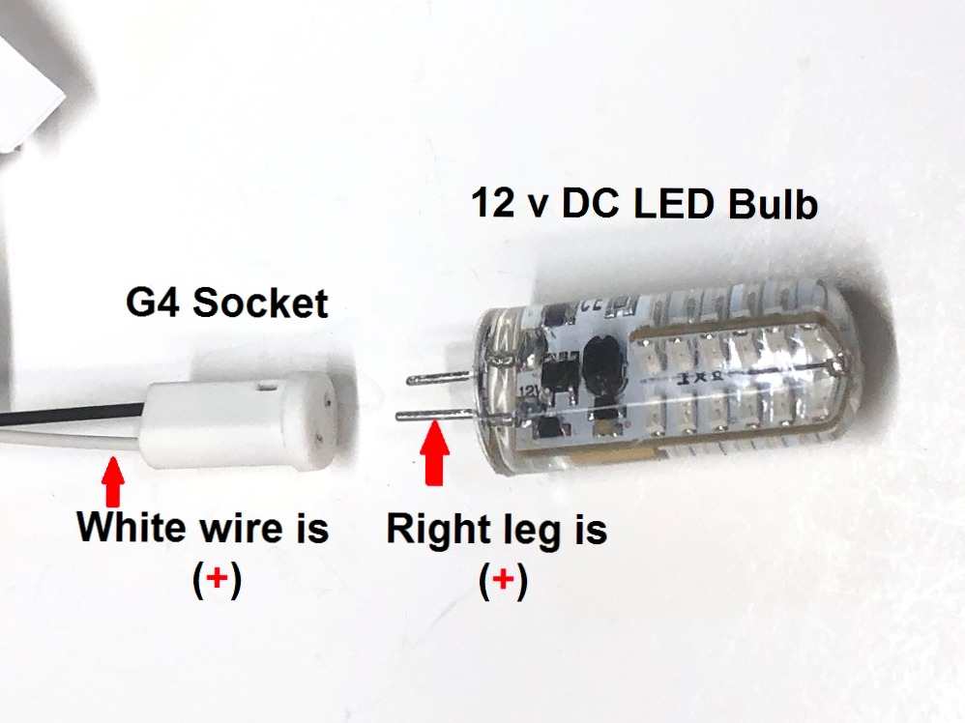
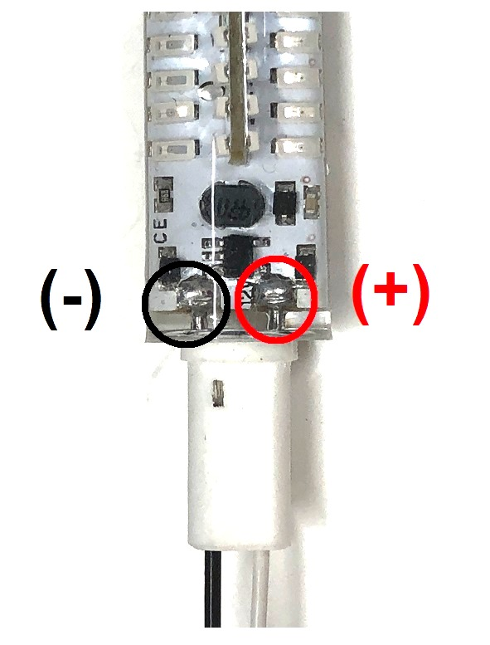
The (+) and (-) polarity of the LED bulbs is indicated by the picture below.

If you have any questions or problems, don’t hesitate to contact me. ENJOY!
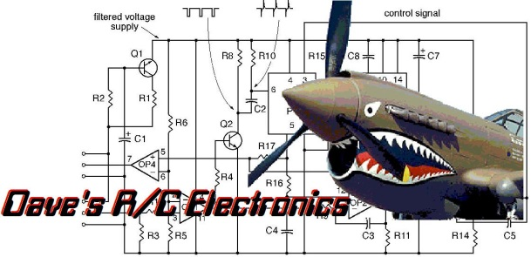
www.davesrce.com
sales@davesrce.com
(423) 544-1657
SCAN HERE

