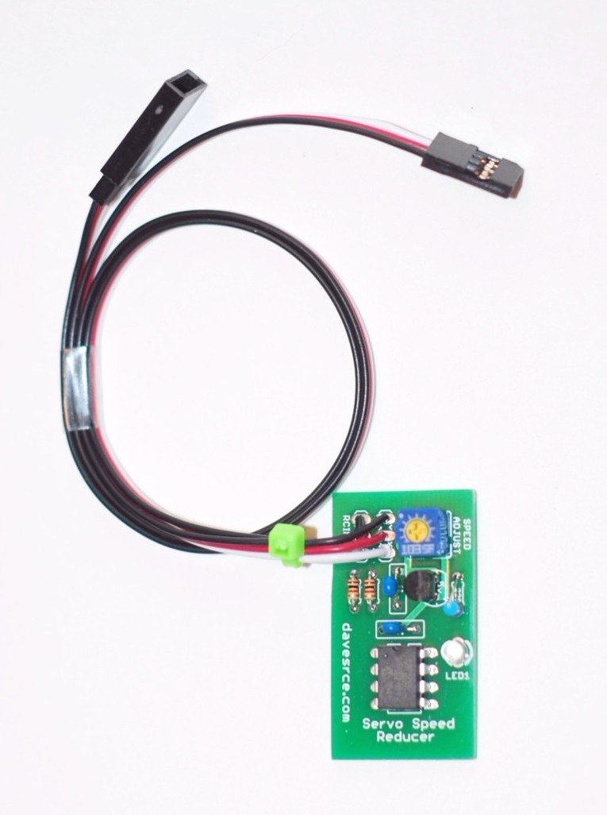
Servo Speed Reducer

The Servo Speed Reducer is a simple device designed to allow you to adjust the speed of almost any servo. Even though many of today’s better radio systems offer this feature as an option during programming, many R/C’ers don’t have the newer equipment, and still may want to slow the action of a servo to make the operation of flaps or retracts look more realistic and scale-like, or to correct the “ballooning” that often occurs when a model’s flaps are dropped suddenly. The Servo Speed Reducer makes it easy to adjust the speed of a servo to fit a variety of situations and needs.
Important Note: This device will only function correctly when connected to a regular, proportional servo. Standard “retract” type servos are not proportional, and their speed cannot be controlled. Their design is such that they only travel from one extreme to the other, either clockwise, or counter-clockwise, and they cannot be made to stop or pause anywhere in between. You can, however, easily modify a regular servo to operate as a retract servo, so that its speed can be controlled as you wish. Instructions on how to do this are easy to find, just search the internet and you’ll find a number of articles that will show you exactly how to do it. If you do decide to modify a regular servo, just remember to use one with sufficient torque to cycle your retracts completely and easily.
Take a moment to familiarize yourself with the operation of your Servo Speed Reducer. Plug it into your receiver, and plug the servo into the female lead coming from the Servo Speed Reducer. If the unit detects power, but no signal from the transmitter, the LED will flash on/off slowly. Make sure the receiver is off, and begin by turning the speed adjustment screw, located near the edge of the circuit board, fully counter-clockwise (CCW). Now turn on the transmitter, then the receiver. The LED on the unit will come on solid (no flash), indicating that the Servo Speed Reducer is allowing the servo to move with no reduction in speed. To adjust the servo to a slower speed, you must first turn the receiver off. This will allow the circuit’s memory to accept a new position of the speed adjustment screw. Failure to turn the receiver off and back on again won’t hurt anything, it just won’t make any change to the speed setting. Now, turn the speed adjustment screw clockwise (CW) slightly, and turn the receiver back on. You will see that the LED is now flashing rapidly, and when you move the servo you’ll see that its speed has been reduced. Turning the speed adjustment screw fully CW will cause the slowest movement of the servo. Experiment with the speed adjustment screw until you find the setting that best suits your tastes and needs. Remember: You must cycle the receiver’s power (turn it off and back on again) each time you adjust the speed adjustment screw for the new setting to take effect.

If you have any questions or problems, don’t hesitate to contact me. ENJOY!
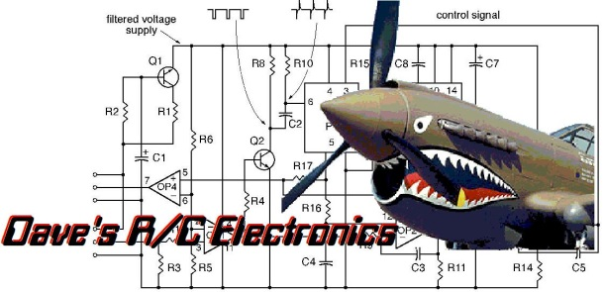
www.davesrce.com
sales@davesrce.com
(423) 544-1657
SCAN HERE

