EC3 & EC5 Connectors

INSTALLATION INSTRUCTIONS

The EC3 and EC5 connectors we sell are the highest-quality connectors we can find, and because of this they may install differently than others you may have purchased from lower-prices suppliers. These instructions will assist you in successfully installing both types.

The brass portions of the EC3/EC5 connectors are the part of the connector that determines the “gender”, i.e. male or female. The brass barrels are considered the female connector, the brass plugs are considered the male connector. (In the US, the metal part of an electrical connector is always the part that determines the gender, not the plastic!) The female (barrel) connectors are always installed on the battery, the male (plug) connectors are always installed on the device that is being connected to the battery (like the ESC). The blue plastic shrouds contain markings that indicate which one is to be paired with the brass connectors, the larger plastic pieces have “DEV” molded into them, they are to be paired with the male brass plugs, and the smaller plastic pieces have “BATT” molded into them, they are to be paired with the brass barrel connectors. Both male and female plastic pieces also have the correct polarity molded into them, the side with the flat, D-shaped opening is always the positive (+) side, the round opening is the negative (-) side.

Tin both the wire and the brass pieces prior to soldering, and partially fill the cavity in the brass connector with solder. Do not overfill, as excess solder will run around the outside of the connector, filling in the grooves that are designed to make the plastic pieces snap into position, and making the diameter of the wire too large to fit into the plastic pieces. If this happens, shake or use a de-soldering tool to remove any excess solder before you try to insert them into the plastic parts. Heat the brass part until the solder is very liquid, and insert the tinned wire into it. Keep heating the brass until the wire is well heated, too, then remove the heat and hold the wire still. This will ensure a solid bond between the brass connector and the wire, and prevent cold solder joints that con rob you of power. (TIP: Wear a cotton glove on the hand you hold the wire with so you can hold the wire steady while it cools.-you’re welcome!)

Now it’s time to insert the brass pieces into the plastic ones, but the wire/brass connectors insert differently in the EC3 and EC5 connectors. There’s a huge difference in the two sizes, so please read carefully. The wires insert into the back of the EC3 connectors, but they insert into the front of the EC5 connectors. If you attempt to insert them incorrectly, you will damage the plastic parts, and they may not hold the brass parts in place when you unplug the two halves of the connectors. Insert the brass connectors into the plastic parts, being sure to observe the correct polarity, as far as you can by hand. Now place the plastic parts on or in a vise, and drive the brass parts into place until they “snap” into position. They should go about ¼” farther into the plastic than they do using hand pressure only, and the brass parts should be almost flush with the ends of the plastic parts.

It takes practice to install these connectors correctly, so take your time and be patient. The EC3 connectors are much harder to install than the EC5, because they insert from the back of the plastic parts. I’ve found that a small awl or a short ice pick helps to drive the brass into position without damaging the wires. The brass on the EC5 can be driven into place using a ball drive hex wrench or other blunt tool.

If you have any questions or problems, don’t hesitate to contact me. ENJOY!
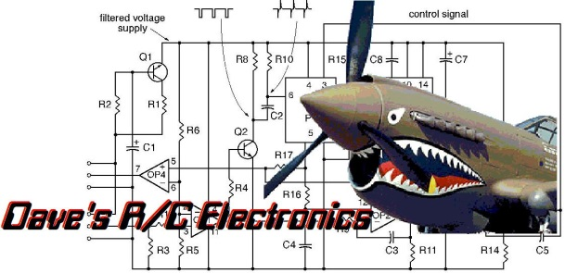
www.davesrce.com
sales@davesrce.com
(423) 544-1657
SCAN HERE

