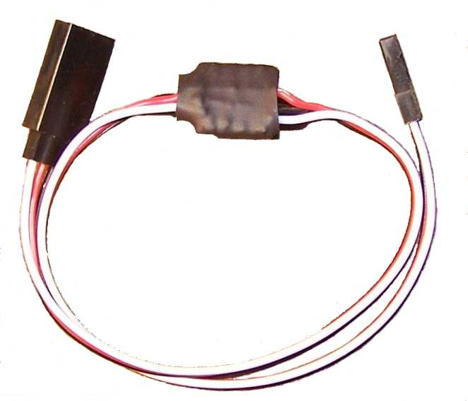

5.0 volt DC Regulator

The 5.0 volt DC Regulator is designed to allow you to reduce the voltage of any circuit to a regulated 5.0 volt output. This circuit uses an L7805CV regulator, combined with capacitors on both the input and the output, to provide a stable, regulated 5.0 volts DC, for use in many radio control applications, like reducing the voltage to LED lights, or making it possible to use normal 4.8-6.0 volt servo with a high-voltage (HV) receiver. The regulator is rated at up to 35 volts DC input, and can provide up to 1.5 amps of regulated current.
Unlike many simple regulators, this circuit also includes a pass-through for the servo’s signal wire, so it can be used with any device that is controlled by or from the receiver/transmitter.
In some cases, you may find that you need to adjust the center position of a servo or other device that are connected together in the same channel. If you do, you may want to consider purchasing one of our Servo Reverser with Trim Pot. It will allow very fine adjustments to the center position of the servo that is reversed, so you can align the operation of the two servos precisely for use on flaps or dual elevators. Check our website for ordering information.

If you have any questions or problems, don’t hesitate to contact me. ENJOY!

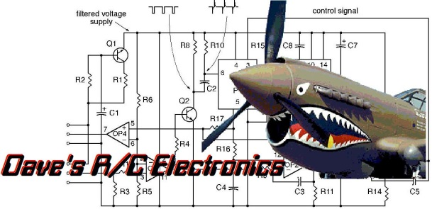
www.davesrce.com
sales@davesrce.com
(423) 544-1657
SCAN HERE

