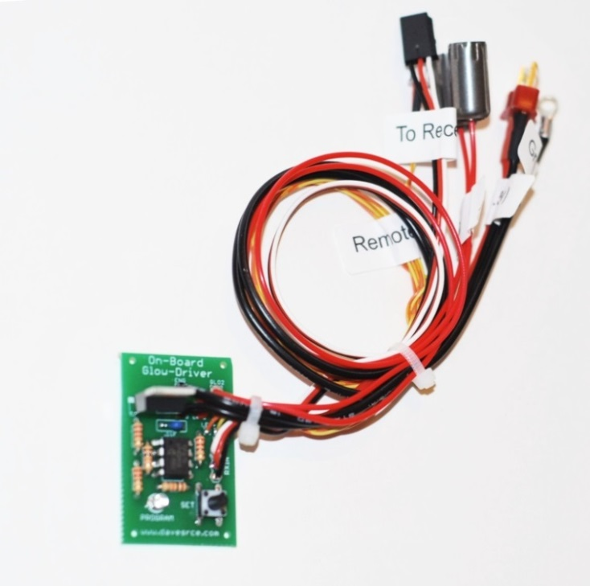
Programmable On-board Glow Driver

The Programmable On-board Glow Driver is designed to provide a steady, reliable idle for any 2 or 4 stroke 2-cycle engine by applying power to the glow plug at low throttle settings. The throttle position at which the glow plug is “on” is fully adjustable, and is set using the throttle stick on the transmitter itself. This setting can be changed as often as desired, and it is stored in the circuit’s memory so it is retained even if the battery in the plane is removed. The Red LED on the main circuit board indicates when the throttle position has been stored to memory, and is also used to indicate when the throttle direction has been successfully reversed. The Orange LED can be mounted anywhere on or inside the model as a visual indicator that the glow plug is “hot”. A single 1.2 volt 2200mAH Ni-Cad Sub-C battery is also included in the kit to provide power to the glow plug so the receiver‘s battery is not drained. (The twin cylinder version includes a two-cell 4400mAh parallel pack for extra power). The Glow Driver itself can either be plugged into your receiver’s throttle channel using a standard servo wye, or can be plugged into a spare channel that is mixed with the throttle channel. If used with a mix, the Glow Driver can then be enabled or disabled with a switch on the transmitter.
Install the Glow Driver in your plane in whatever manner you prefer, the location of the components is not critical, but it should be positioned so that you can access the Throttle Position Set Switch on the main circuit board at least until the correct throttle position can be set. Plug the 3-pin servo lead into your receiver, and connect the 1.2 volt Sub-C battery to the Deans plug coming from the circuit board. Connect the long red wire with the black boot onto your engine’s glow plug, and secure the long white wire with the ring terminal on one end to one of the engine’s mounting bolts. The white wire must be grounded to the engine for the circuit to work properly. The Orange LED can be mounted anywhere on the model that is convenient, i.e. on the side of the fuse or on the instrument panel under the canopy. I suggest you locate it so that you can see it easily as you attempt to start the engine. A black plastic holder is included for the LED to make the installation neater. Once you’re satisfied with the throttle set point and are sure that everything is working correctly, the Glow Driver circuit board can be wrapped in foam or bubble wrap (my favorite) and secured inside the fuse with screws, Velcro, cable ties, or whatever fastener you prefer. Secure the 1.2 volt battery inside the fuse as well, but be sure to position it so that you can get to the Deans plug easily to disconnect the battery when not in use and for charging.
(continued on back)
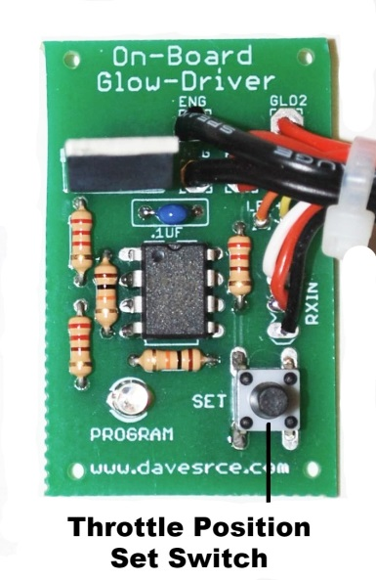

When powered for the first time, the Glow Driver will have a throttle position stored in its memory that will light the glow plug at approximately ¼ throttle. To choose a new set point, follow these instructions:

- Turn on the transmitter, then the plane, and move the throttle stick to the position where you want the glow plug to come on.
- Press and hold the Throttle Position Set Switch (see picture) for about 2 seconds. The Red LED on the circuit board will blink twice to indicate that the throttle position has been successfully stored. Now, whenever the throttle stick is moved to or below this position, the glow plug will be hot, and the Orange LED will be on.
- If you find that the operation of the circuit is backwards, that is, the glow plug is “on” at high throttle settings and “off” at low settings, the circuit’s operation can easily be reversed. Repeat steps 1 and 2 above, but once the Red LED has blinked twice to indicate the set position has been stored, release the button and quickly press and hold it again. The Red LED will now blink three times, to indicate the throttle’s direction has been reversed.
- Your Programmable On-board Glow Driver is now ready to use.

To recharge the 1.2 volt battery, simply unplug the Deans connector from the Glow Driver, and connect it to your favorite Ni-Cad charger. Most chargers will automatically detect the number of cells and adjust the charge voltage and current settings accordingly. If necessary, manually set your charger’s output to charge a single, 1.2 volt 2200mAh Ni-Cad battery. You can also modify a common glow igniter charger (like a “Hot Shot”), just splice into the wires somewhere near the end that connects to the glow plug, and add a couple of short wires with the male Deans plug on the end that is included in the kit. Be careful to match the polarity of the wires on the battery to the wires coming from your charger.

If you have any questions or problems, don’t hesitate to contact me. ENJOY!
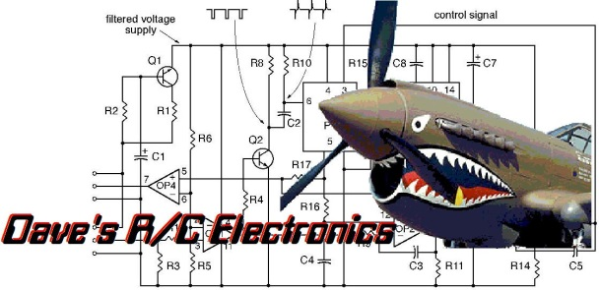
www.davesrce.com
sales@davesrce.com
(423) 544-1657
SCAN HERE

