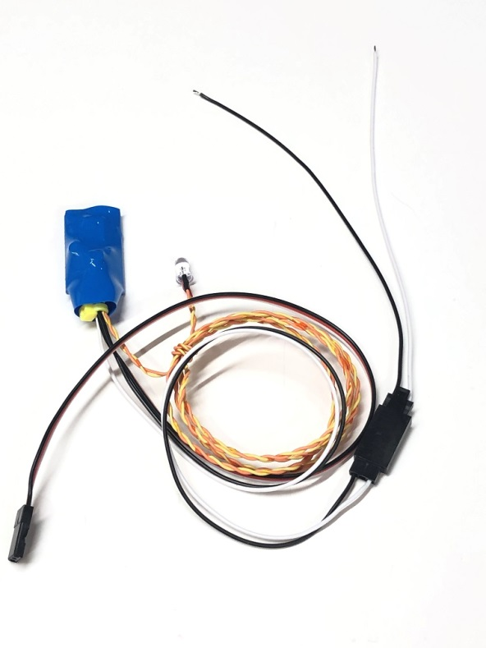

**Magneto Kill Switch**

The Magneto Kill Switch is designed to allow the modeler to disable the spark on a gas engine that uses a magneto ignition system. It plugs into the receiver, and connects to both the engine’s chassis and to the magneto’s grounding terminal. It is then able to detect the state of the channel to allow the spark to be disabled from the transmitter.

To install the Magneto Kill Switch, simply plug the servo cable into the receiver channel you wish to use, making sure that the end points of the channel are set to 100% in both directions, and assign a switch on the transmitter to control the channel. The black and red wires should be routed through (or around) the firewall to the engine compartment, with the black wire connected to the engine’s frame, and the red wire connected to the magneto’s ground terminal. The remote LED can be installed anywhere on the model where it is easily visible, cockpit area, fuselage, etc. If you don’t want or need a visual indication of when the ignition is “on”, you can remove the LED or leave it coiled up inside the model.

Check the operation of the switch by toggling the switch used to control the channel. When the LED is “off”, the magneto is grounded and there is no spark. When the LED is “on”, your ignition should be active and the spark available for normal engine operation. The JST disconnect is provided for convenience in removing either the switch or the motor without having to remove the switch’s wiring.

***If you have any questions or problems, don’t hesitate to contact me. ENJOY!***

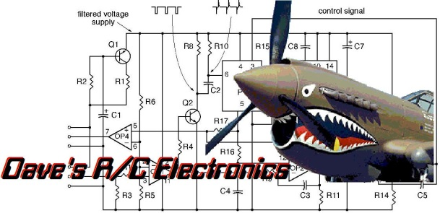



www.davesrce.com

sales@davesrce.com

(423) 544-1657

**SCAN HERE**