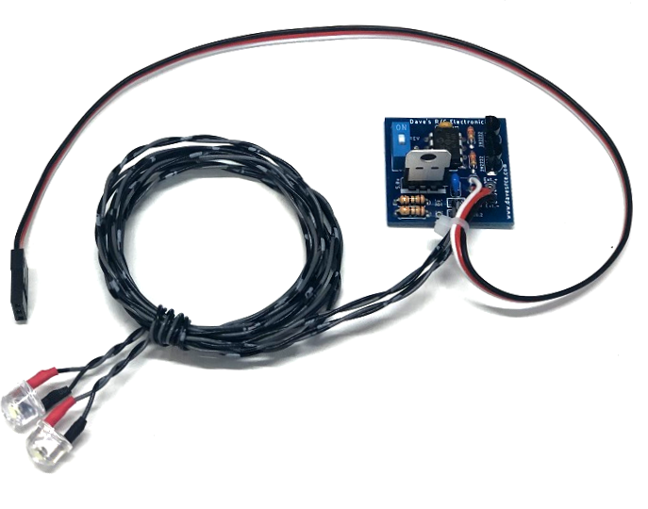
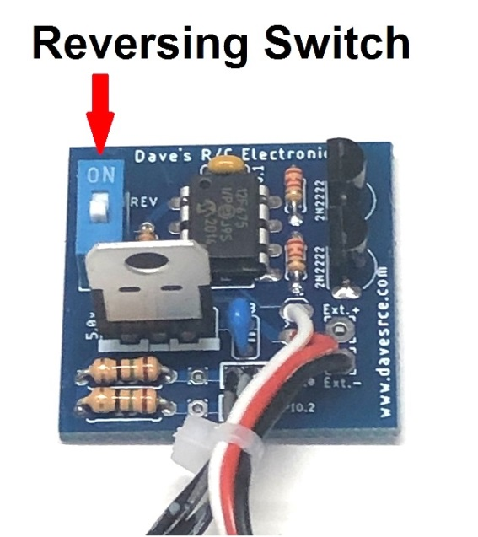
Wig-Wag Landing Lights-8mm (Giant Scale)

This kit will provide everything you need to install a pair of Landing Lights on your model. It features the unique pulsing action commonly referred to as a “Wig-Wag” pattern that is scale for many float planes like the DeHavilland Beaver or the Piper Bushmaster. The LEDs are switchable from the transmitter, and the circuit can be reversed for easy installation in a model that is already setup and programmed with flaps or retracts. The LEDs used are 8mm high-brightness ½ watt LEDs that are specifically designed to be visible at an extreme angle (120 degrees), and to provide the brightest output possible from an LED this size and at the lower current levels necessary for an R/C model. The circuit is voltage regulated, so it is suitable for use on almost any receiver, including high-voltage receivers using 2 and 3-cell Li-Po/Li-Fe batteries. The unit is powered by the receiver's battery, so no additional battery is required, which means almost no added weight, and no extra battery to replace or recharge.
The servo lead coming from the main circuit board is connected to your receiver using either a spare channel, or it can be connected via a servo “Y” to the gear or flap channels. If connected to a dedicated (spare) channel, the lights will come on/off whenever the switch on the transmitter that is assigned to that channel is toggled. If connected to the gear or flaps via a servo Y, the lights will come on whenever the gear or flaps are lowered. The blue DIP switch on the left side of the main circuit board is used to reverse the action of the circuit, toggling it will change on which side of center the LEDs are “on”. (See picture above ) If you are using this circuit in a model that already has retracts or flaps, and the LEDs are coming on at the wrong time, simply toggle this switch to reverse the action of the circuit.
The wires from the LEDs can be connected to any kind or type of 2-pin disconnect you prefer if necessary for easy wing removal. NOTE: The transmitter and receiver must both be on for the circuit to work!

If you have any questions or problems, don’t hesitate to contact me. ENJOY!
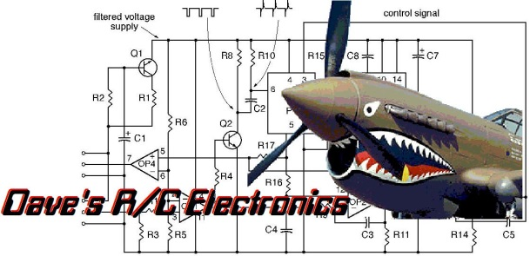
www.davesrce.com
sales@davesrce.com
(423) 544-1657
SCAN HERE

