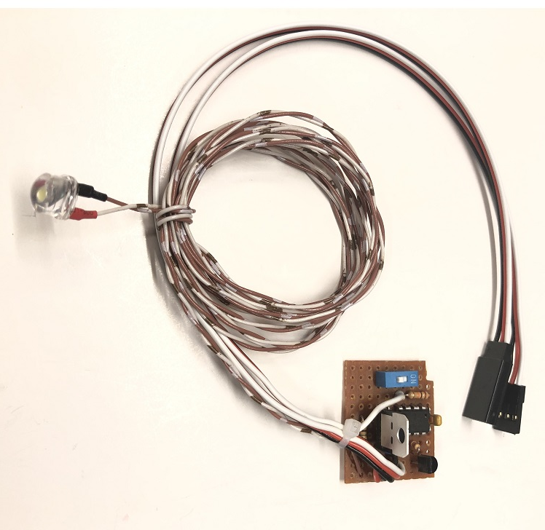

Warbird Landing Light & Servo Control

The Warbird Landing Light & Servo Control is designed to coordinate the movement of a single servo and an 8mm ½ watt, High-Brightness LED, to provide the circuit necessary to replicate the landing light that rotated down and out of the bottom of the wing on many WWII warbirds. (There are several pages on the Internet and Facebook that include information on making brackets that will mount on a servo to move a hinged door up and down.) The circuit is switchable from the transmitter, and can be connected either to a separate spare channel, or connected using a standard servo Y to the gear channel along with air or electric retracts. It features an on-board reversing switch that allows the modeler to sync the action of the circuit so that it works correctly with your retracts, i.e. up/off and down/on, thus eliminating the need to change the settings of the retracts. It is regulated, so it is compatible with any receiver voltage, including HV receivers. The voltage going to the servo, however, is not reduced, so it will cause no reduction in torque or speed, even if using HV servos.
Operation is simple, and automatic. Connect the female servo connector to the channel of your choice, and connect the male servo connector to the servo that rotates the landing light door. If the model has retracts, move the gear to the down position, and note the state of the LED, i.e. on/off. If the LED is off when the gear are down, move the on-board reversing switch to the opposite position. Once the LED is on when the gear are down, and off when the gear are up, you can connect the linkages to the servo to move the door to the down position as required.

If you have any questions or problems, don’t hesitate to contact me. ENJOY!
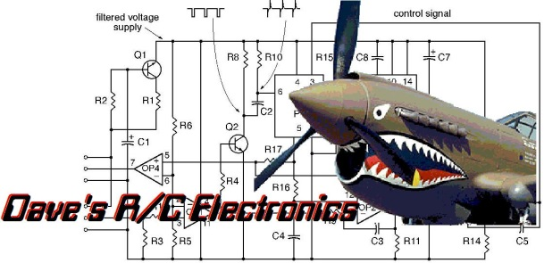
www.davesrce.com
sales@davesrce.com
(423) 544-1657
SCAN HERE

