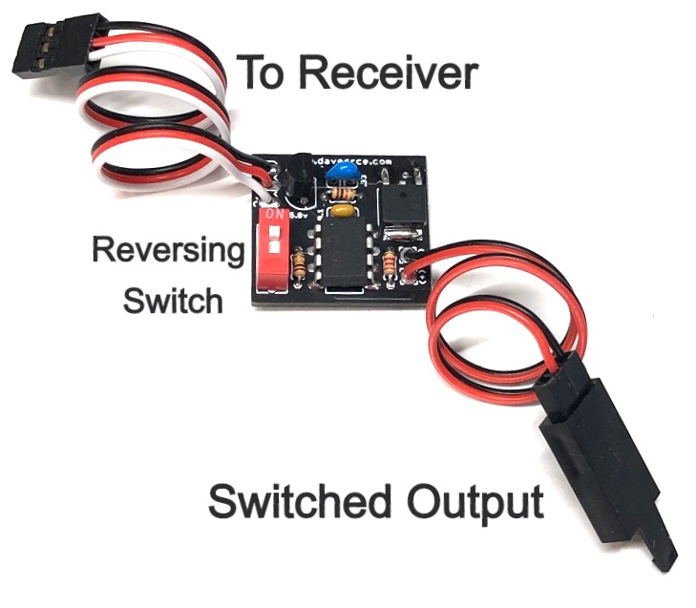

**Simple R/C Switch**

The Simple R/C Switch is designed to allow you to control a variety of devices that are connected to your model’s receiver using your transmitter. The circuit is designed specifically to be easy to use, it plugs directly into a spare channel on your receiver, and the device you want to switch on/off is connected to the cable coming from the circuit board. A small DIP switch allows you to reverse the action of the switch without changing the channel’s settings in your radio, allowing it to be used in conjunction with other devices or circuits that may already be configured for that channel’s settings. It especially useful for switching LEDs like those that are commonly used for navigation lights, and can be added to models that come pre-equipped with LEDs that are not switchable from the transmitter.

The Simple R/C switch includes an onboard regulator, so the switch can be used with any radio/receiver system, including "standard" 4.8 - 5.0 volt systems and high-voltage (HV) receivers running at 6.6 - 7.4 volts.

To reverse the action of the Simple R/C Switch, simply move the small blue switch from one position to the other, and the on/off action of the circuit will be reversed.

**Note: The output of this switch is the same as the receiver's voltage.  Any LEDs connected to the output of this switch should be connected to a current-limiting resistor of the appropriate size for that voltage.  Make sure any other devices being switched are compatible with the receiver's voltage.**

***If you have any questions or problems, don’t hesitate to contact me. ENJOY!***

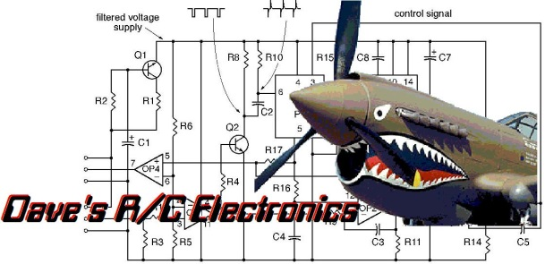

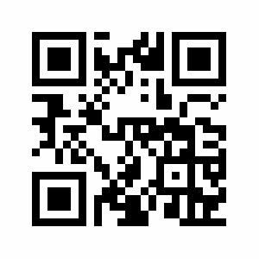

www.davesrce.com

sales@davesrce.com

(423) 544-1657

**SCAN HERE**