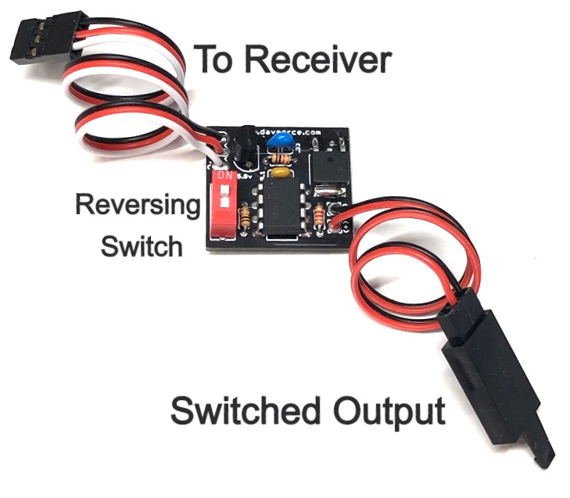
Standard □
High-Voltage (HV) □

Simple R/C Switch

The Simple R/C Switch is designed to allow you to control a variety of devices that are connected to your model’s receiver using your transmitter. The circuit is designed specifically to be easy to use, it plugs directly into a spare channel on your receiver, and the device you want to switch on/off is connected to the cable coming from the circuit board. A small DIP switch allows you to reverse the action of the switch without changing the channel’s settings in your radio, allowing it to be used in conjunction with other devices or circuits that may already be configured for that channel’s settings. It especially useful for switching LEDs like those that are commonly used for navigation lights, and can be added to models that come pre-equipped with LEDs that are not switchable from the transmitter.
The Simple R/C switch is available in two different versions, one is non-regulated, and is designed to be used on receivers that are powered by a 4.8-6.0 volt battery (4 or 5-cell Ni-Mh), or from a 5.0-6.0 BEC, as is normal with most electric powered models that have an ESC. The second version is designed to be used on high-voltage (HV) receivers that are powered by 2S LiFE, 2S or 3S Li-Po/Li-Ion battery packs.
To reverse the action of the Simple R/C Switch, simply move the small blue switch from one position to the other, and the on/off action of the circuit will be reversed.
Note: The output of the HV version of this switch is not regulated. Any LEDs connected to this switch should be connected to a current-limiting resistor of the appropriate size for the receiver’s voltage.

If you have any questions or problems, don’t hesitate to contact me. ENJOY!
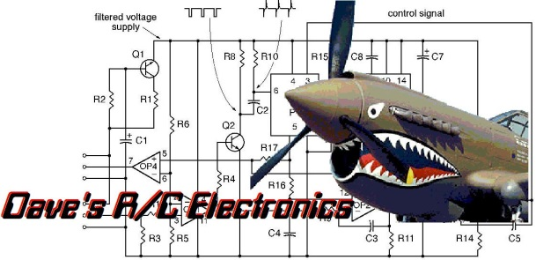
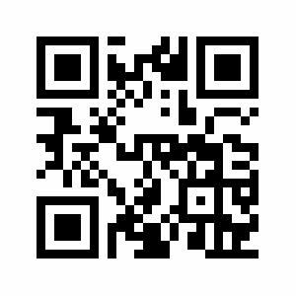
www.davesrce.com
sales@davesrce.com
(423) 544-1657
SCAN HERE

