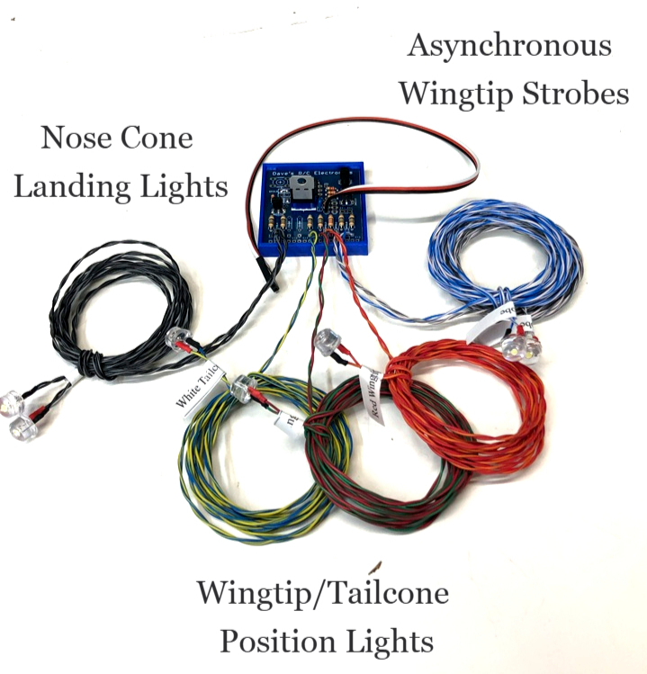
Legend Hobbies OA-1K NavLights-8mm

The Legend Hobbies OA-1K NavLights is designed to plug into any spare channel on your receiver, and provides two Wingtip Navigation Lights (1 x red/1 x green), two Asynchronous Wingtip Strobes (white), one Tailcone/Rudder Light (white), and two Nose Cone Landing Lights, all of which are switchable from the transmitter. The Asynchronous Wingtip Strobes are set to a double-blink pattern that alternates from one to the other in a pattern that is scale for this aircraft.
In order to allow the various outputs to be switched from the transmitter, the circuit should be plugged into a proportional channel, typically channel 6 or higher. Adjust the ATV or End Points of the channel you choose to 100% in each direction, and assign a switch or knob to control the channel. Avoid using the gear channel unless you are certain that your radio allows proportional control of the gear channel.
Note: If your gear channel isn’t proportional, you can still use it for the lights, but you will only have Mode #2 and Mode #3 (see chart below). Just adjust the lower end point up until the navigation and strobe lights come on, then the gear switch can be used to turn the nose cone lights on/off.
This circuit has 3 modes, which respond to approximately the programmable channel mixes shown below:

Mode #1: All Lights OFF---0% (-100%)
Mode #2: All Lights - except Landing Lights - ON-------- greater than 25% (-50%)
Mode #3: All Lights ON (including Nose Cone Lights) ------ greater than 50% (0% or channel center)

If used in conjunction with our Drop-Down Landing Lights Kit, you can program a mix to make the nose cone lights in this set come on at the same time the Drop-Down Lights are down and on.

If you have any questions or problems, don’t hesitate to contact me. ENJOY!
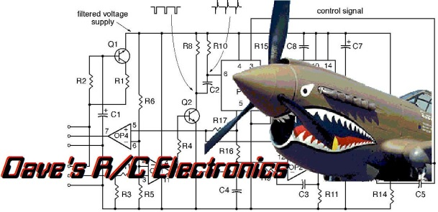

www.davesrce.com
sales@davesrce.com
(423) 544-1657
SCAN HERE

