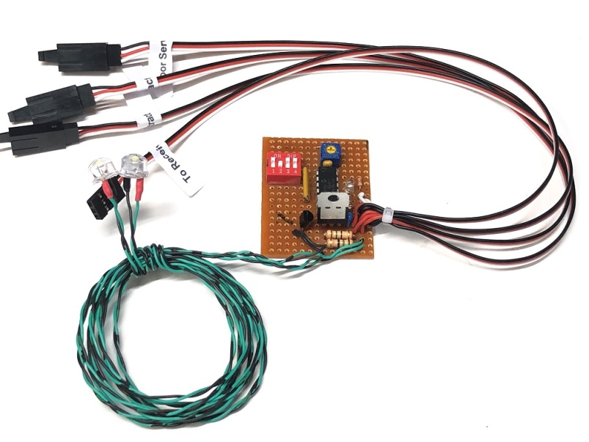
Deluxe Retract and Gear Door Sequencer

The Deluxe Retract and Gear Door Sequencer is designed to provide coordinated control of the retract controllers and gear door servos used on a plane equipped with both, and utilizes a microprocessor to control both. It also features Landing Lights that can be set to come on when the gear are down, and provides the option of leaving the gear door(s) open after the gear have been lowered (P-47 style), or having the gear door(s) close after the gear are down (P-51 style). An adjustable delay allows the modeler to time the opening/closing of the model’s gear doors to accommodate the speed of the model’s retracts. Multiple gear door servos may be controlled at the same time with the use of a standard servo Y. It also allows the modeler to choose to enable a 3-second delay on the right gear when moving to the Up position, to simulate the action of many WWII Warbirds.

The controller can be located inside the model in any convenient location. The female servo lead from the controller will normally be connected to the receiver’s gear channel, although it can be connected to any spare channel and activated via a program mix. Two of the male servo leads are connected to the right and left retract controllers, and the third is connected to the gear door servo(s), all are clearly marked. A small potentiometer near the top of the circuit board provides adjustment for the delay function, which can range from 0 seconds (no delay) to approximately 10 seconds. (Sequencers with a longer delay are available, just give us a call). Turning the screw clockwise (CW) decreases the delay, turning it counter-clockwise (CCW) increases the delay. The red Option Switches on the left side of the board control the other functions of the sequencer. Switch #1 toggles the action of the Landing Lights, and determines when the lights are on or off. Once the controller and gear doors are setup correctly, this switch allows you to sync the Landing lights with the position of the gear. (This switch is normally left in the “On” position.) Switch #2 reverses the direction (rotation) of the gear door servo(s), to facilitate easier setup with different model configurations. Switch #3 controls whether or not the gear doors close after the gear have been lowered. If “Off”, the doors will remain open after the gear have been lowered, if “On”, they will close. (Gear doors will always close after the gear have been raised.) Switch #4 determines if the right main will be delayed by approx. 3 seconds when coming up. This delay is active if this switch is “On”.

(continued on back)

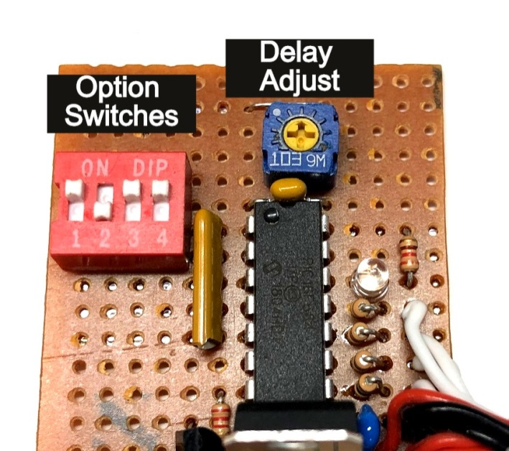

To prevent damage to your gear doors, new programming prevents either servo from moving when the receiver is first powered. Once the gear switch has been cycled once, the retract controller will move to the indicated position, and the gear doors will cycle in accordance to the way they are set up using the instructions that follow. Follow them carefully to prevent damage to your gear doors during the initial setup.

Leave the linkage to your gear door servo(s) disconnected until you have completed steps 1 through 7 completely!

1. If you want the gear doors to close after the gear have been lowered, turn the screw on the small pot located at the top edge of the circuit board fully counter-clockwise (CCW). This will provide maximum delay for the setup procedure. If your gear doors are to remain open after the gear are lowered, you can skip this step.
2. Make sure all three Option Switches are “OFF”. This will prevent the gear doors from closing until you have established the correct direction of rotation for your gear door servo(s), and have made sure that the gear switch on your transmitter is operating in the direction you prefer.
3. Connect the cables from your retract controller and gear door servo(s) to the proper male servo leads as marked. Connect the cable marked “To Receiver” to your receiver’s gear channel, or to the channel of your choice.
4. Power your receiver on. Note that the retracts and gear door servos will not move until you cycle the gear switch one time. Toggle it, and note the yellow LED on the main circuit board, it will indicate which mode the sequencer is in. If the yellow LED is On, that is the Gear Down mode. If it is off, that is the Gear Up mode. Move the switch on your transmitter to the position you prefer for Gear Down, and note if the LED is on. If it is not, simply reverse the channel in your transmitter. Cycle the gear switch several times to make sure the sequencer is in sync with the position of the retracts. Once your gear move up and down correctly and are in sync with the sequencer, note the state of the Landing Lights. If the LEDs are not “On” when the gear are down, and “Off” when they are up, move Option Switch #1 to the “On” position. Now proceed to step 5.
5. Note the direction that the gear door servo is rotating, either clockwise or counter-clockwise (CW or CCW). If it is rotating in the wrong direction, move Option Switch #2 to the “ON” position. Cycle the gear up and down several times to verify that the gear door servo is moving in the right direction to open the gear doors when the gear are down, and close them when the gear are up.
7. If you want the gear doors to remain open after the gear are down, make sure Option Switch #3 is in the “OFF” position, and skip to Step 8. If you want the gear doors to close after the gear have moved “Down” (P-51 style), move Option Switch #3 to the “ON” position. Cycle the gear to the “Gear Down” position, and note the delay between the time the gear are fully down and locked and the closing of the gear doors. (Be patient, the initial delay will be about 10 seconds.) If the delay is too long, turn the screw on the pot clockwise (CW) in small increments and cycle the gear again. Repeat until you find the setting that provides the correct timing for your retracts.
8. Now connect the linkages to the gear door(s) and make any necessary final adjustments.

Following the steps above should ensure that your sequencer works smoothly and reliably.

If you have any questions or problems, don’t hesitate to contact me. ENJOY!
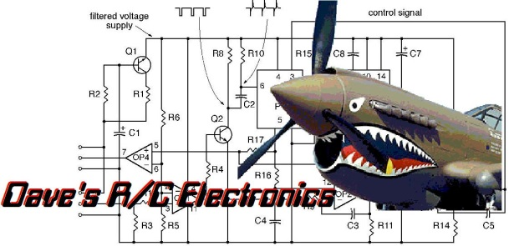
www.davesrce.com
sales@davesrce.com
(423) 544-1657
SCAN HERE

