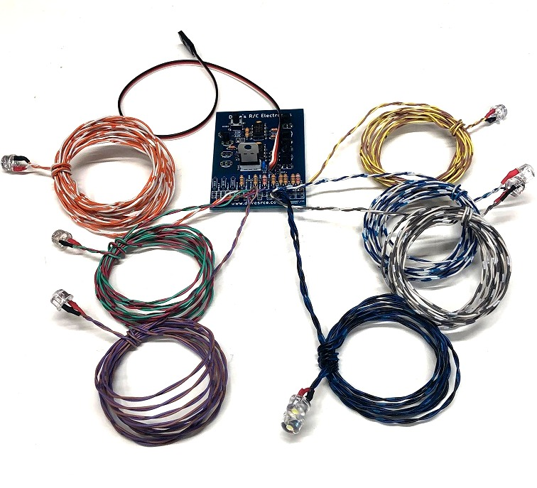
BlackHorse Viper Navigation Lights

The Blackhorse Viper Navigation Light Set is designed to plug into any spare channel on your receiver, and provides two Wingtip Navigation Lights, two Wingtip Strobes, a Fuse/Rudder Strobe, two Landing Lights, and a Nose Wheel Landing Light, all of which are switchable from the transmitter. It also features 4 different strobe patterns that can be selected by the small push-button switch located on the main circuit board. The 4 patterns cycle between single and double-blink patterns for each set of strobes (fuse and wingtip). The last pattern chosen is stored to the circuit’s memory so that it retains the setting even after the plane’s battery is removed.
In order to allow the various outputs to be switched from the transmitter, the circuit should be plugged into a proportional channel, typically channel 6 or higher. Avoid using the gear channel unless you are certain that your radio allows proportional control of the gear channel. Adjust the ATV or End Point of the channel you choose to 90-95% in each direction, but no more than 100%. The channel you select should be one that can be controlled with a knob or slider, and/or a 3-position switch. The Custom All-in-One Navigation Light Set has 3 modes, which respond to approximately the programmable channel mixes shown below:

Mode #1: All Lights Off ------------------------------------- 0% /-100%
Mode #2: Navigation Lights and Strobes On --------- greater than 25% / -50%
Mode #3: All Lights On (including Landing Lights --- greater than 50% / 0% (or channel center)

(continued on back)

Plug the circuit into the receiver, and rotate the knob fully Counter-clockwise (CCW), all lights should be Off. If they are not, (all ON) reverse the channel in the transmitter’s programming. As you advance the channel you selected from low to high, you should see the lights come on in the order of the 3 modes above. If you wish, you can use a 3-position switch and programmable mixes to control the 3 modes.

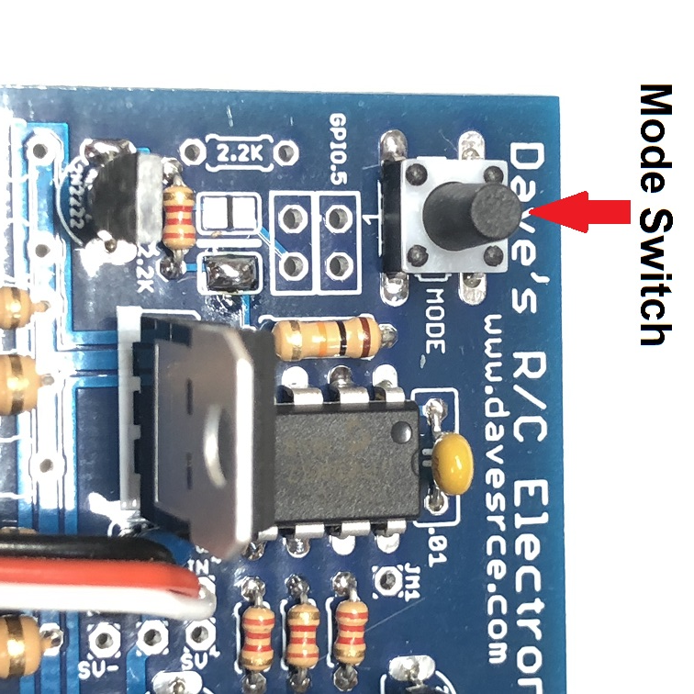
The 4 available patterns can be selected via the small pushbutton switch on the main circuit board. (See picture above). The 4 patterns are listed below:

#1: Single-blink Fuse Strobe/Single Blink Wingtip Strobes
#2: Double-blink Fuse Strobe/Double Blink Wingtip Strobes
#3: Single-blink Fuse Strobe/ Double Blink Wingtip Strobes
#4 Double-blink Fuse Strobe/Single Blink Wingtip Strobes

Once you’ve scrolled through all 4 patterns, the next button press will cause all the LEDs to fade up and down, indicating you’ve gone through the available patterns and are about to re-start at pattern #1. About 15 seconds after your last selection, the circuit will save that pattern to its memory so it will start in that pattern every time, unless (or until) it is changed again.

If you have any questions or problems, don’t hesitate to contact me. ENJOY!
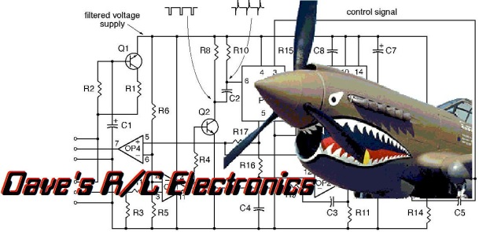

www.davesrce.com
sales@davesrce.com
(423) 544-1657
SCAN HERE

