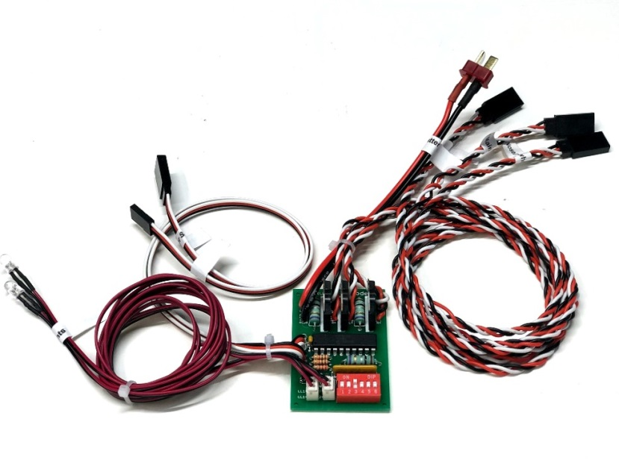
C3DL Deluxe Retract Controller

The C3DL Deluxe Retract Controller is designed to control up to 3 small to medium-sized brushed-motor retracts. It contains current-sensing circuitry designed to stop the voltage to the gear motors when they have moved to the end of their limits, or whenever a mechanical obstruction is detected. This prevents over-driving of gear motors that may cause damage to the controller and/or gear motors, over-heating of the wiring, or draining the retract battery too quickly. It also features a selectable 2 or 3-gear configuration, and independent reversing of the nose/tail wheel motor. On-board switches allow you to choose from a number of options that adapt the controller to a wide variety of models and configurations. This manual will explain the circuit’s operation and the options available.
The C3DL Deluxe Retract Controller is designed to power the gear motors from a separate battery, to eliminate the danger of the retracts draining the receiver battery and causing a catastrophic failure. It should be sized according to the recommendations of the manufacturer of the retract motors. Consult your retract’s instructions for information on the size of the battery required, or consult us for advice.
CAUTION: To prevent damage to the retract battery, disconnect it from the controller when not in use. Alternately, you may install a switch between the retract battery and the controller.

Installation and Configuration of Options Switches

- Connect your retract battery to the connector labeled “Retract Battery”.
- Plug the female servo lead labeled “To Receiver” into any spare channel on your receiver (usually this will be the gear channel). Make sure that the End Points, or ATV, of the channel used for the controller are set to a minimum of 75% in both directions (-75% and +75%). On initial power-up, the controller will attempt to move the landing gear to the down (landing) position, to prevent the gear from moving up and damaging the model if the gear switch on your transmitter is not in the landing position. The controller will wait until the transmitter’s gear switch is in the “down” position before allowing control of the gear. The gear channel may be reversed in the transmitter’s programming to orient the gear switch to suit the modeler’s preference for Gear Up and Gear Down. The controller will still execute the Gear Down command upon initial power-up.
(continued on back)

- Connect your retracts to the male servo leads coming from the board, labeled “Right Main”, “Left Main”, and, if present, “Nose/Tail Wheel”.
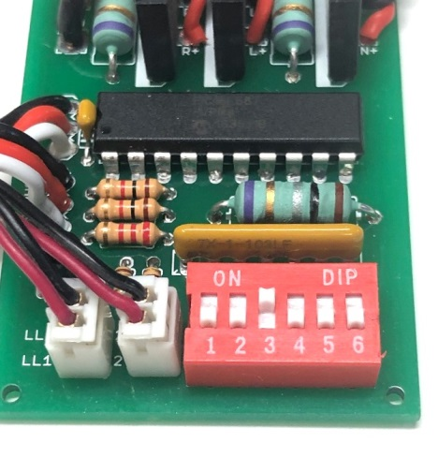
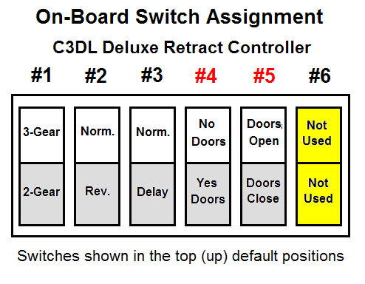
- Connect your Gear Door Servo’s cables (if present) to the lead marked “Gear Door Servo”. If you have more than one gear door servo, you can use a standard servo Y to connect them all to this cable.

The red Option Switches near the bottom of the circuit board are used to configure the controller’s various functions. Follow the instructions below to set them to your preferences.
Note: It is not necessary to disconnect power to the controller or to unplug it from the receiver before making changes to the Option Switches, they can be changed “on the fly”. Any changes made will be implemented in the next movement of the appropriate gear.

- If your model is equipped with 3 landing gear, leave Option Switch #1 in the “3-Gear” (top) position. If your model does not have a nose or tail wheel, you should disable the nose/tail wheel output by moving Option Switch #1 to the “2-Gear” position (down). This step is important; failure to set this switch correctly will prevent the controller from working as it should.
- If your nose or tail wheel moves in the same direction as the main gear, leave Option Switch #2 in the “Norm.” (top) position. If your nose/tail wheel moves in the opposite direction from the main gear, it can be individually reversed by moving Option Switch #2 to the “Rev.” position (down). Once you have all 3 gear moving in the correct direction for your model, you can reverse them all by reversing the gear channel in your transmitter, to your preference.
- To simulate the landing gear characteristics of many warbirds, the “Right Main” gear can be delayed for 2 seconds as it moves up by moving Option Switch #3 to the “Delay” (down) position. The delay function is disabled as the gear moves down.
- If your model has gear doors, Option Switch #4 should be in the “Yes Doors” (down) position. If it does not have gear doors, move it up to the “No Doors” (top) position.
- If you want the gear doors to close after the gear are down, move Option Switch #5 to the “Doors Close” (down) position. If you want them to remain open, move it to the “Doors Open” (up) position.
- Option Switch #6 is not used in this model controller.

(continued on back)
Landing Lights

Your controller is equipped with an individual output that is designed to power one or two 5mm LEDs that can be used to simulate landing lights on your model. This manual will detail both the connection of the LEDs to the controller and their operation.
There are two red JST connectors coming from the main circuit board marked “Landing Lights”. Plug 1 or 2 LEDs into one or both of these connectors and locate the LEDs as desired on the model itself. Wires may be shortened or lengthened as necessary, just use any small-gauge wire (like speaker wire or “zip” wire), available in most any hardware or electronic supply store. Since the controller knows when the landing gear have been dropped to the landing position, it will control the landing lights without any further programming of your transmitter or the use of any other switches.
Operation of the landing lights is simple, once the gear have moved to their fully down position, the landing lights will come on and stay on until the gear are retracted again. The LEDs are powered by the receiver’s flight battery, drawing only 25-30mA each

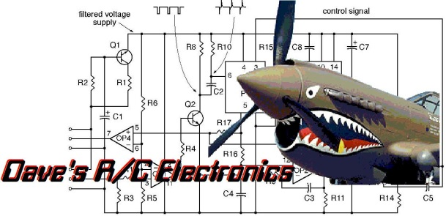
If you have any questions or problems, don’t hesitate to contact me. ENJOY!
www.davesrce.com sales@davesrce.com
(423) 544-1657
SCAN HERE

Deluxe Controller Troubleshooting Guide
Problem: |  | Possible Solutions:
When plane is turned "On", nothing happens-gear do not move. |  | - Make sure batteries are fully charged.  - Check battery connections for correct polarity.  - Check gear motor connections for correct polarity.  - Make sure connectors are plugged in all the way, and are lined up correctly (White/Red/Black).
When plane is turned "On", gear begin to move down, but one does not move, or stalls before it is all the way down. |  | - Check for binding or obstructions in the movement of each gear, they must be free to move.  - Mounting flanges must be level so that the gear body is not twisted or torqued. Loosen the mounting screws and re-test with mounting screws loose.  - If you are using an extension between the controller and the motor, remove it and hook the gear directly to the controller.
When plane is turned "On", gear move down and stop, but will not come back up. |  | - Make sure all gear motors are connected properly. On a 2-gear system, both gear motors must be connected. On a 3-gear system, all three gear motors must be connected, or the nose/tail wheel must be disabled using option switch #1.  - Make sure transmitter is turned "On".  - Make sure end points (or ATV) on transmitter’s gear channel are set to at least 75% in both directions.
Nose/Tail wheel is not moving. |  | - Make sure Option Switch #1 is UP (top) 3 gear selection.
Nose/Tail Wheel moves in the wrong direction. |  | - Move Option Switch #2 to the other position.
Left Main gear does not move up immediately, but hesitates for 3-4 seconds before moving. |  | - Make sure option Switch #3 is in correct position. UP is for normal operation, DOWN for delay.
Gear doors do not move, or they close or do not close at the correct times. |  | - Make sure Gear Door Option Switches are in the correct position. Refer to your instruction manual for the location and information on setting them correctly for your controller.

